Computer Networks Laboratory Week 1

Name : Tanishq Vyas
SRN : PES1201800125
Section : H
Semester : 5
Branch : CSE

TASK 1 : Linux Interface Configuration (ifconfig / IP command)

Interface Name | Ip Address | MAC Address
wlo1 | 192.168.43.249 | ff:ff:ff:ff:ff:ff
lo | 127.0.0.1 | 00:00:00:00:00:00

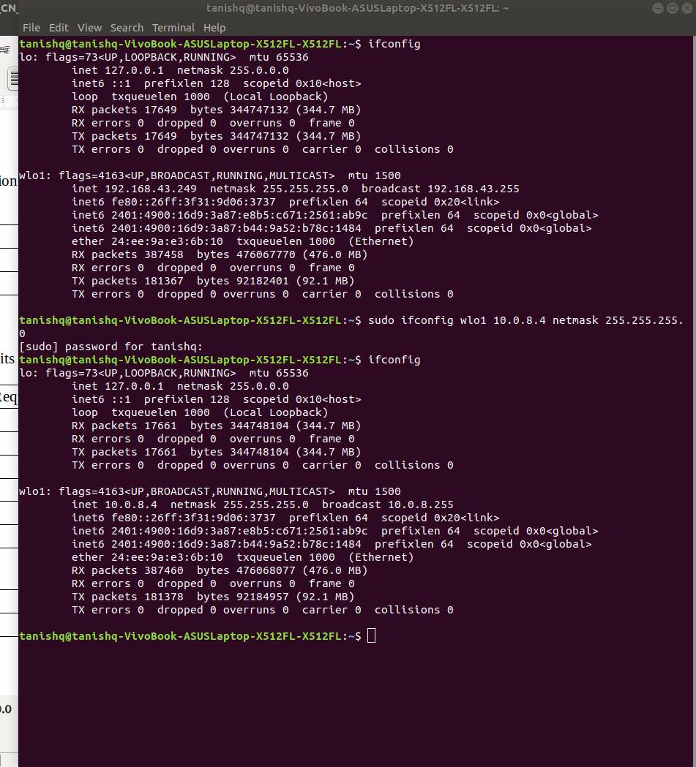
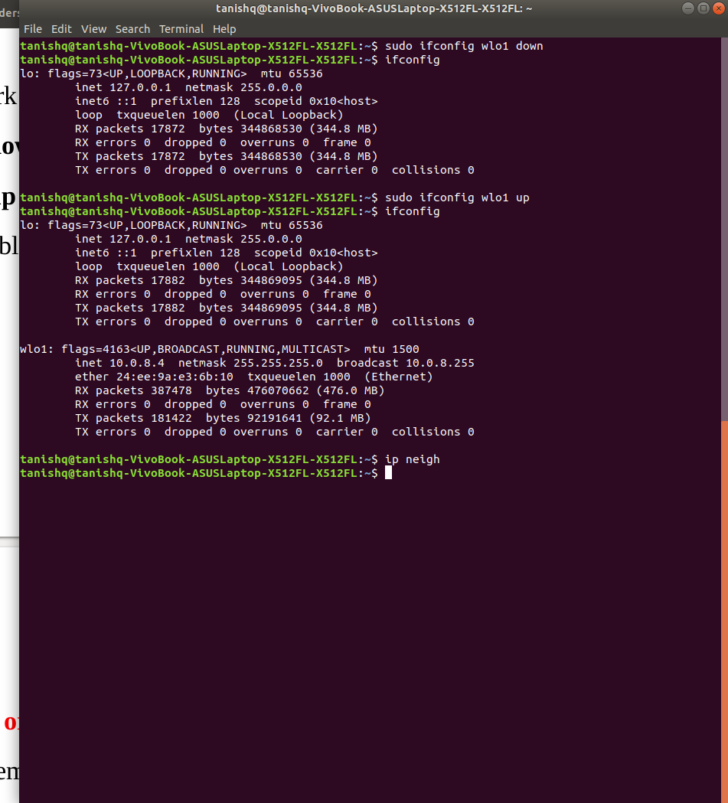

TASK 2 : Ping PDU (Packet Data Units or Packets) Capture

Details | First Echo Request | First Echo Reply
Frame Number | 3 | 4
Source IP address | 10.0.8.4 | 10.0.8.4
Destination IP address | 10.0.8.4 | 10.0.8.4
ICMP Type Value | 8 | 0
ICMP Code Value | 0 | 0
Source Ethernet Address | 00:00:00:00:00:00 | 00:00:00:00:00:00
Destination Ethernet Address | 00:00:00:00:00:00 | 00:00:00:00:00:00
Internet Protocol Version | Version 4 | Version 4
T Time To Live (TTL) Value | 64 | 64

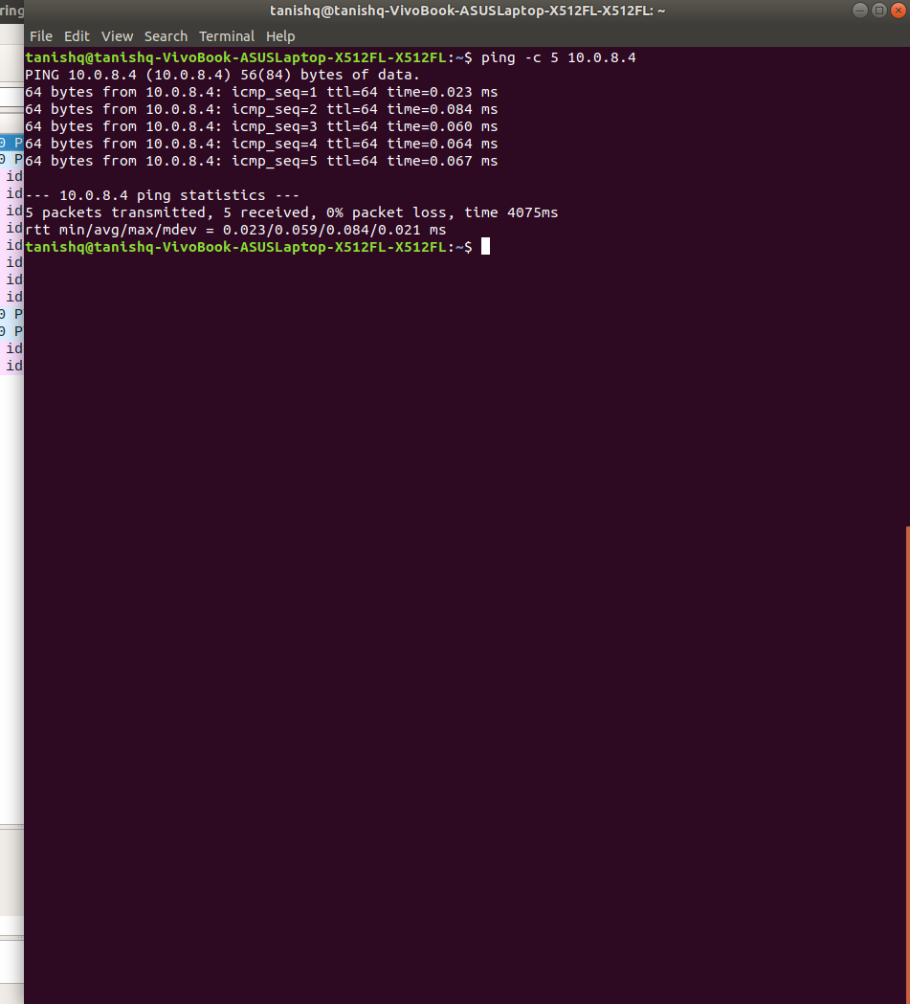
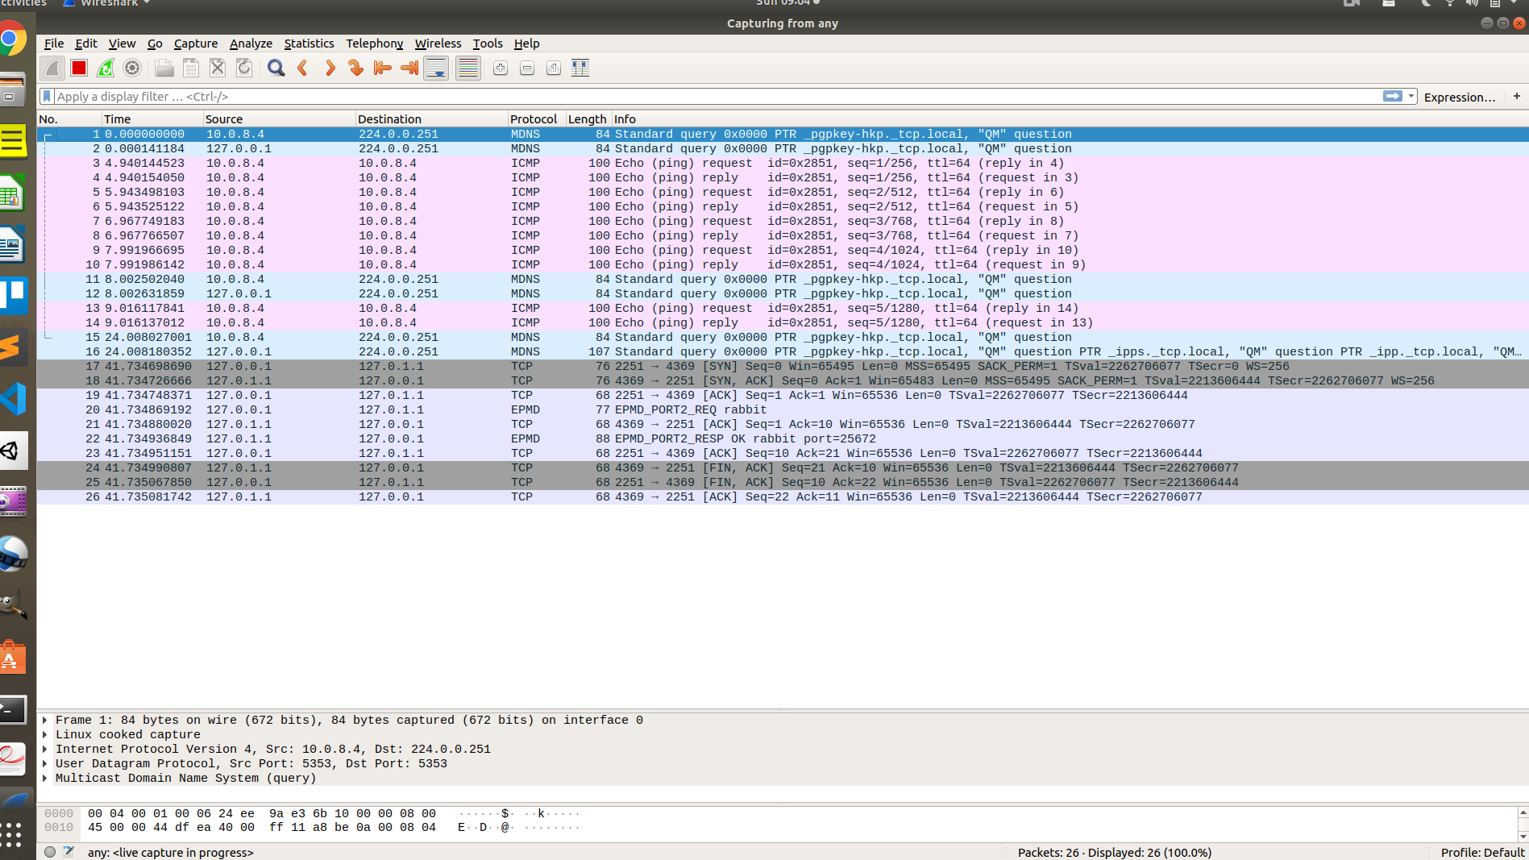
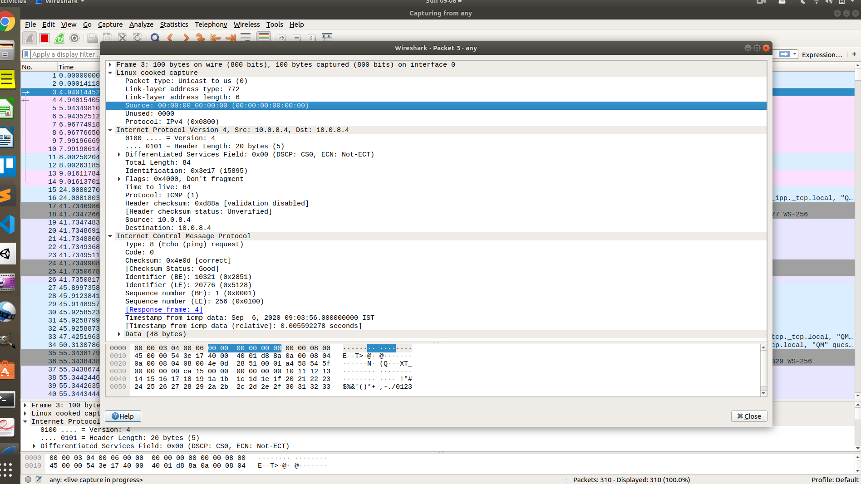

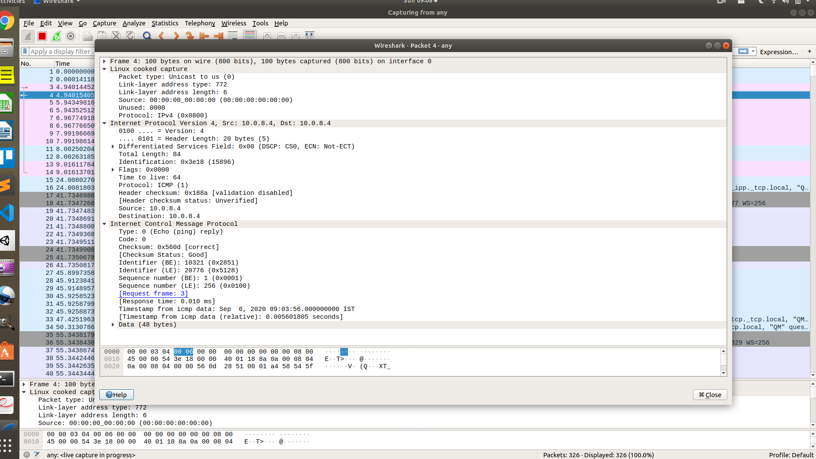

TASK 3 : HTTP PDU Capture

Details | First Echo Request | First Echo Reply
Frame Number | 360 | 362
Source Port | 5596 | 80
Destination Port | 80 | 5596
Source IP address | 192.168.43.249 | 15.207.162.112
Destination IP address | 15.207.162.112 | 192.168.43.249
Source Ethernet Address | 24:ee:9a:e3:6b:10 | 18:f0:e4:87:c1:81
Destination Ethernet Address | 18:f0:e4:87:c1:81 | 24:ee:9a:e3:6b:10

HTTP Request |  | HTTP Response
Get | GET / HTTP/1.1\r\n | Server | nginx/1.18.0\r\n
Host | www.freeclan.net\r\n | Content-Type | NA
User-Agent | Mozilla/5.0 (X11; Linux x86_64) AppleWebKit/537.36 (KHTML, like Gecko) Chrome/85.0.4183.83 Safari/537.36\r\n | Date | Sun, 06 Sep 2020 03:48:54 GMT\r\n
Accept-Language | en-GB,en-US;q=0.9,en;q=0.8\r\n | Location | http://www.freeclan.net/
Accept-Encoding | gzip, deflate\r\n | Content-Length | NA
Connection | keep-alive\r\n | Connection | keep-alive\r\n

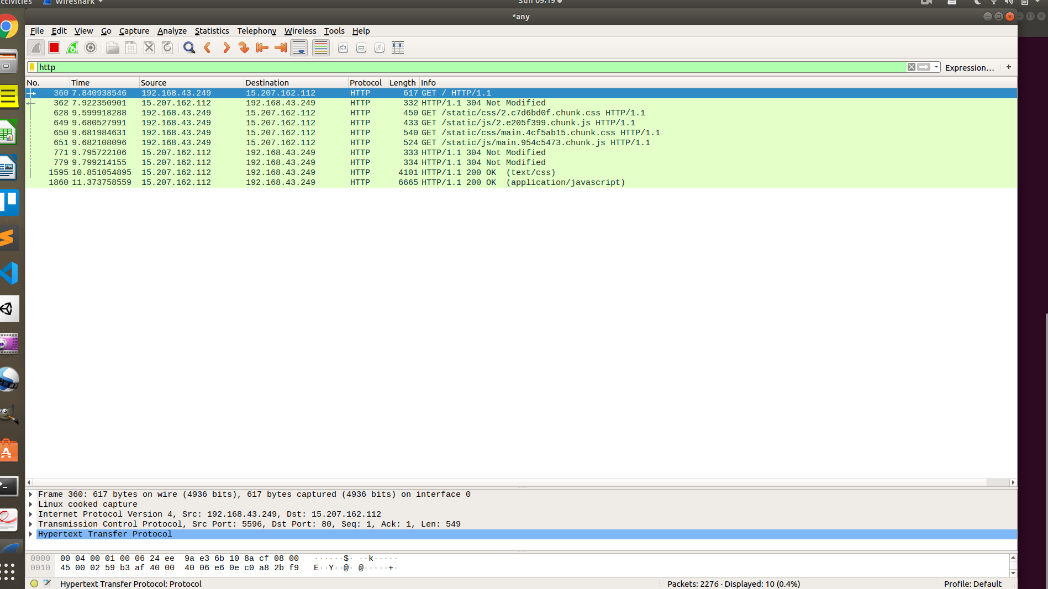
Fig : HTTP Filter for website
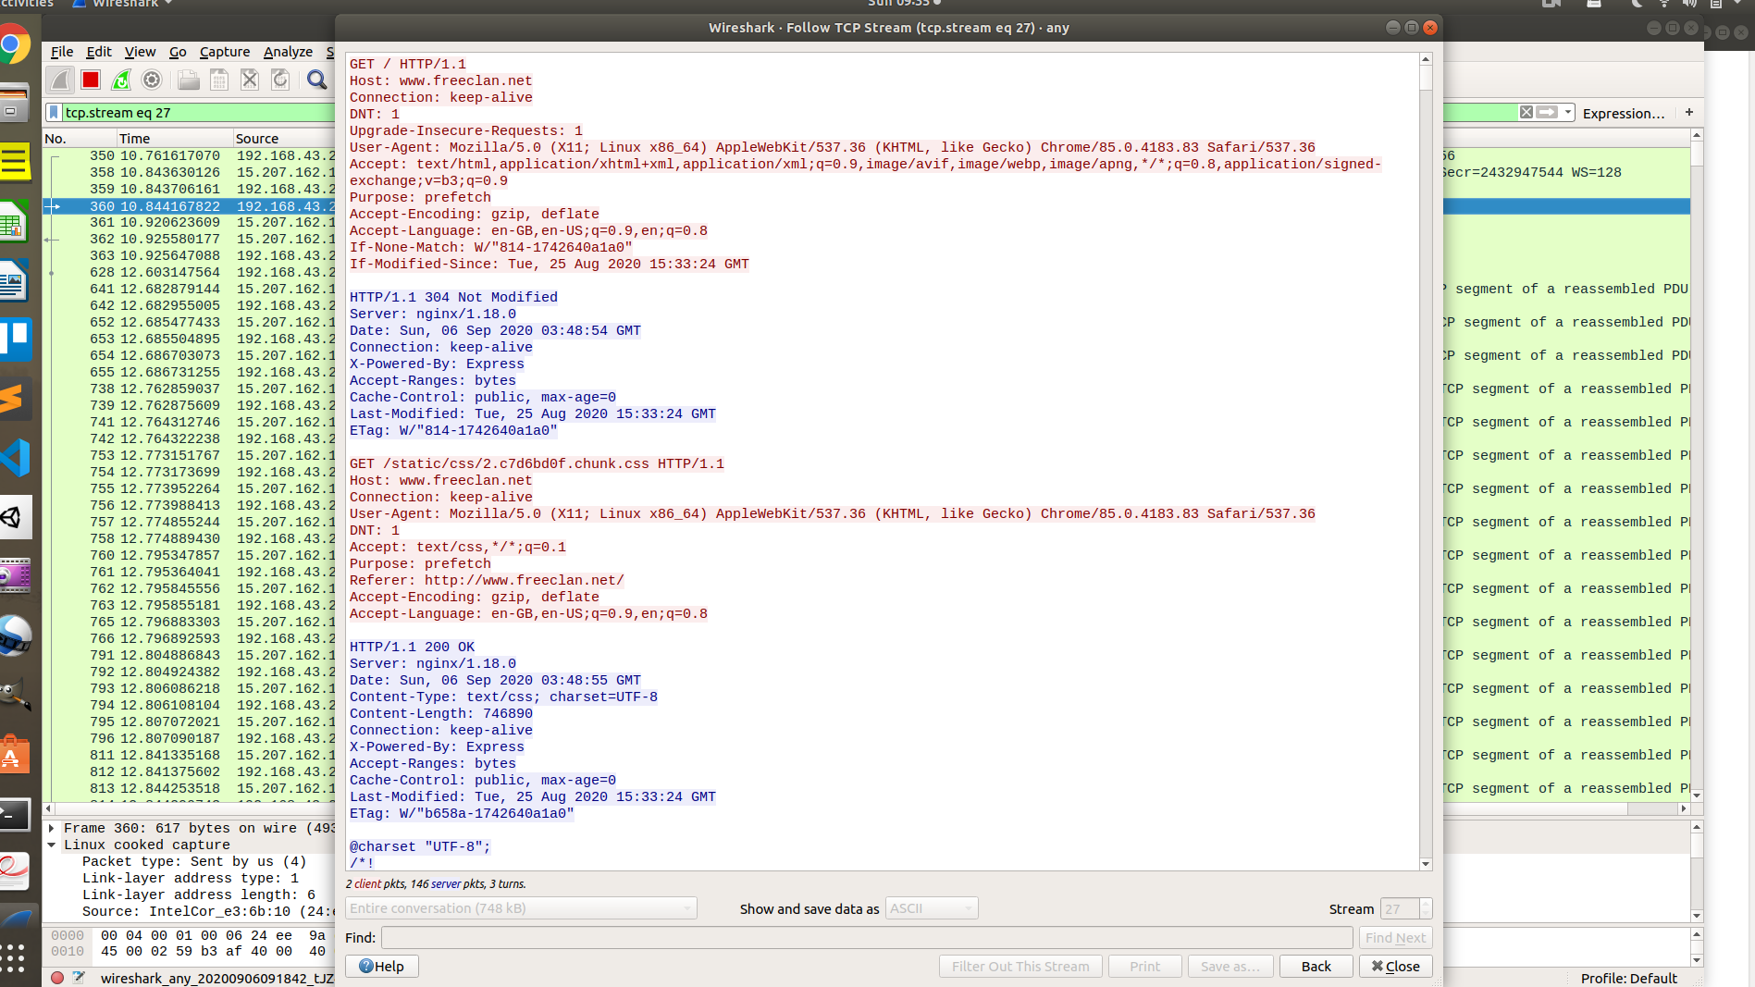
Fig : Follow TCP Stream

TASK 4 : Capturing packets with tcpdump

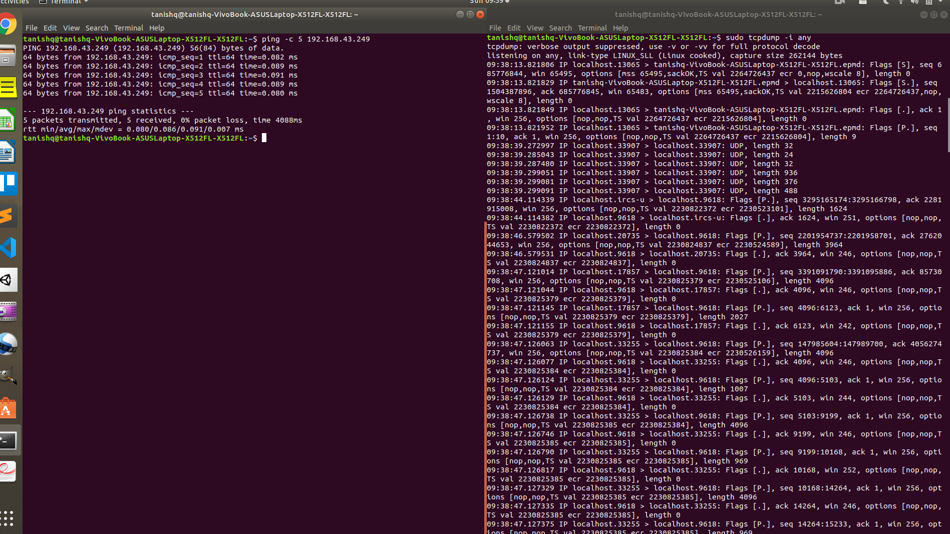

Task 5: Perform Traceroute checks

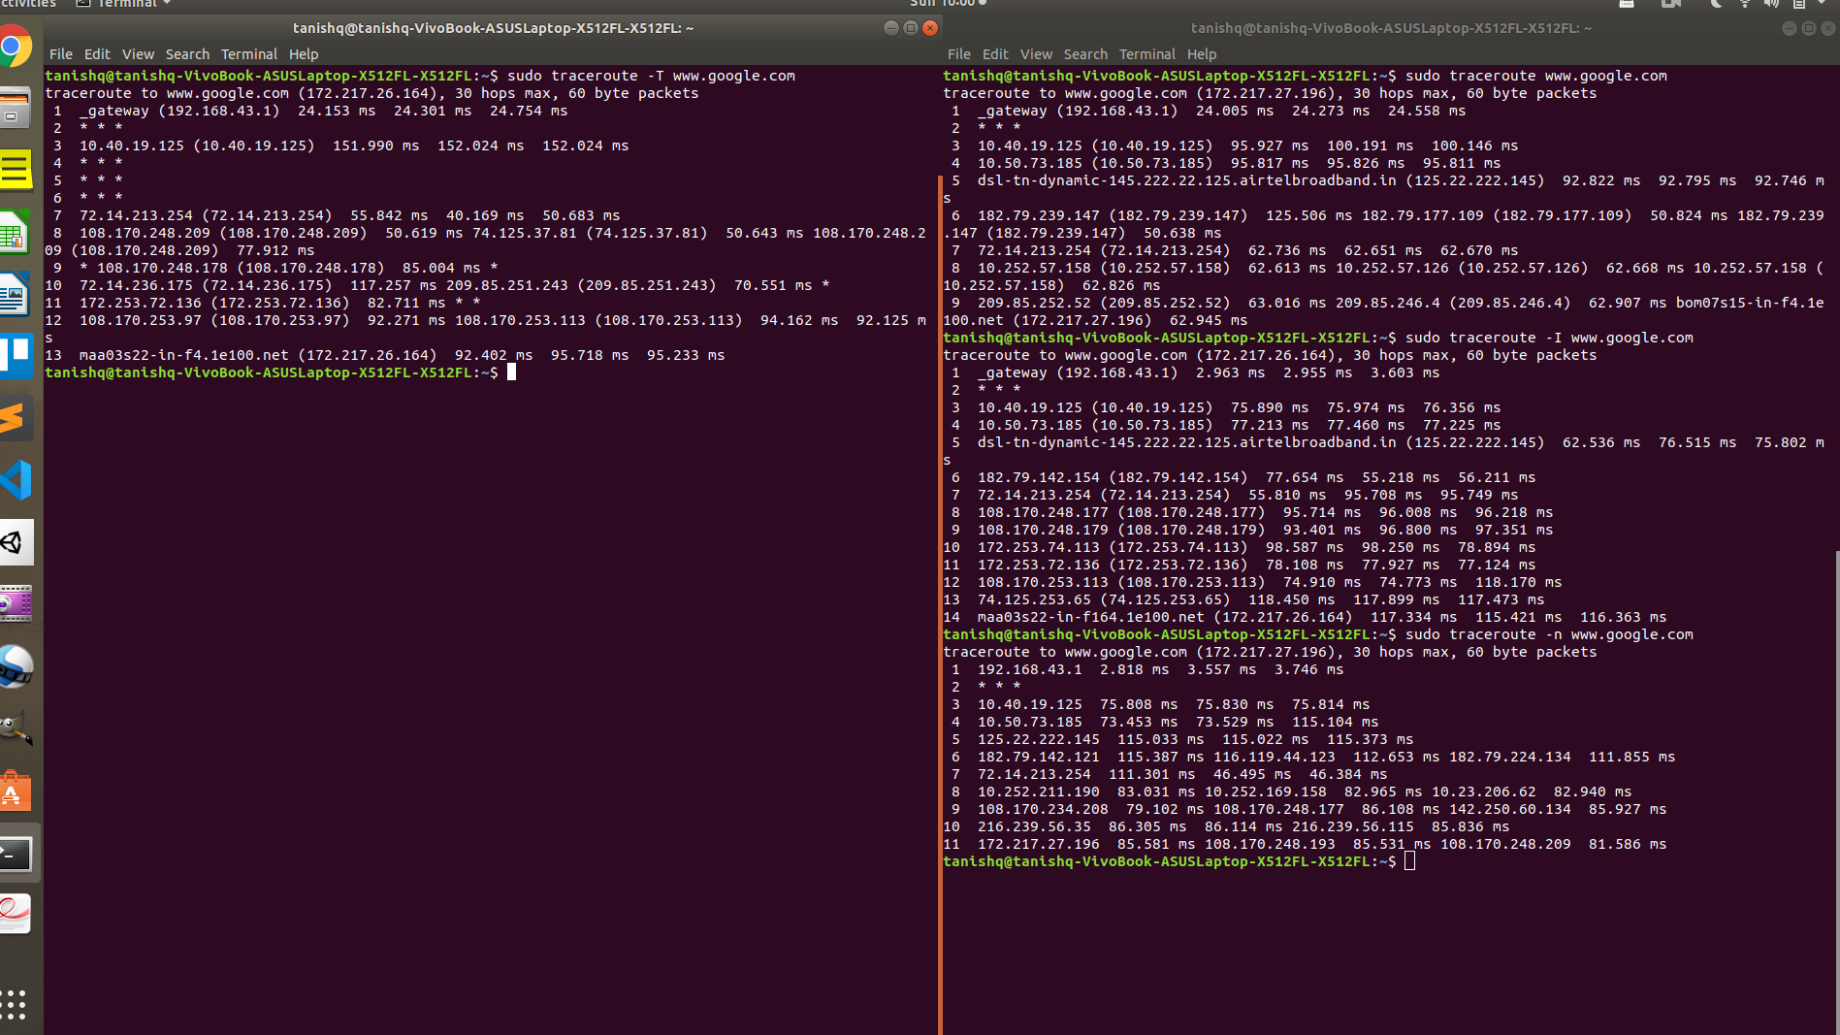

Task 6: Explore an entire network for information (Nmap)

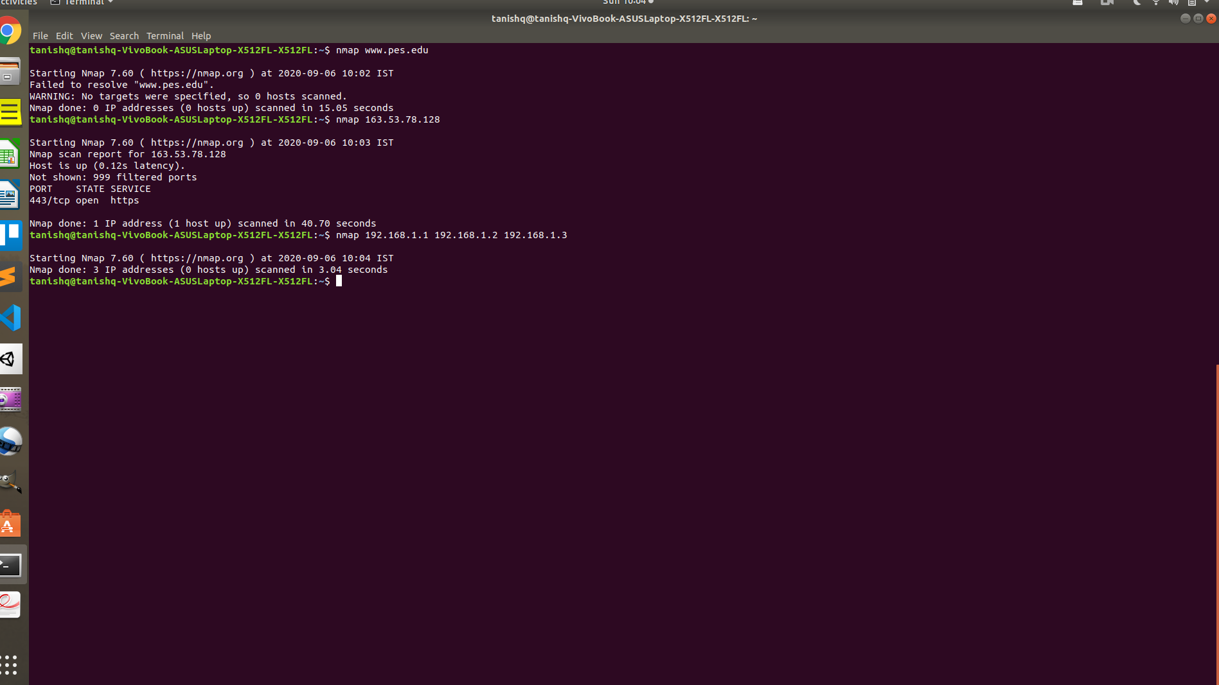

Answers :

1. Browser is running HTTP/1.1 and the Server is running HTTP/1.1 version. We see this in the request & response for a given communication between the client and server.

2. last-modified: Tue, 25 Aug 2020 15:33:24 GMT
this header helps us to know when was the file last modified.

3. In order to tell ping to send, let’s say N packets then stop, we make use of -c argument.

Eg: To ask ping to stop after 4 packets we will use the command

ping -c 4 mywebsite.com

4. we can make use of nmap command in order to get the information for the same

$ nmap -O -v server.ip.address

This helps us to get the information for the OS and apps.

